BHARATHIDASAN UNIVERSITY

URUMU DHANALAKSHMI COLLEGE

KATTUR-19

PG & RESEARCH DEPARTMENT OF PHYSICS

TITLE: **Analyzing the performance & Efficiency of the Radisson hotels using data visualization techniques**

TEAM MEMBERS:

1)M.MADHAVAN

2)A.ARJUN SURYA

3)G.ARAVINDHAN

4)M.PRASATH

INTRODUCTION

**The hotel industry is a broad category of businesses that provide lodging services for travellers and tourists. This can include a wide range of establishments, from luxury resorts to budget-friendly motels, as well as extended stay hotels, boutique hotels, and more. Hotels can be found in nearly every corner of the world, and are often a major component of the tourism and travel industry in a given area.**

**Radisson owns multiple five-star hotels across India. They have been in the hospitality industry for the past 100 years. Due to strategic moves from other competitors and ineffective decision-making in management, Radisson is losing its market share and revenue in the luxury/business hotels category. As a strategic move, the managing director of Radisson wanted to incorporate Business and Data Intelligence in order to regain their market share and revenue. Our task is to create an analytics dashboard & story to provide them insights to make better business decisions.**

PURPOSE

Radisson executed a technique named as "complaint card" that was utilized to gather visitor criticism at the end of their stay in the hotel.  This project was unsuccessful because numerous visitors did not even finish them; as a result the organization was required to take some different measures. Radisson could enhance the experience of customers by giving membership benefits and discount programs. Customers who visited on a continuous basis may get a steeper discount than consistent inn rates.  Guests who fill out the card completely or take a review over the Internet may get a ten percent rebate off their following visit.  Customer recognition is a vital idea, particularly in an industry that characterizes their services as an "experience."  By improving their services for customers with completely coordinated information frameworks, they provide astounding solid and reliable services.  With these set-up measures, satisfaction of employees and customers remain predictable and continue to progress constantly.

ADVANTAGE

1. **Simple sharing of data –**   
   With the representation of the information, organizations present another arrangement of the correspondence. Rather than sharing the cumbersome information, sharing the visual data will draw in and pass on across the data which is more absorbable.

DISADVANTAGE

1. **One-sided –**  
   The essential arrangement of information representation occurs with the human interface, which means the information that turns out to be the base of perception can be one-sided. The individual bringing the information for the equivalent may just think about the significant part of the information or the information that requirements center and may reject the remainder of the information which may prompt one-sided results.  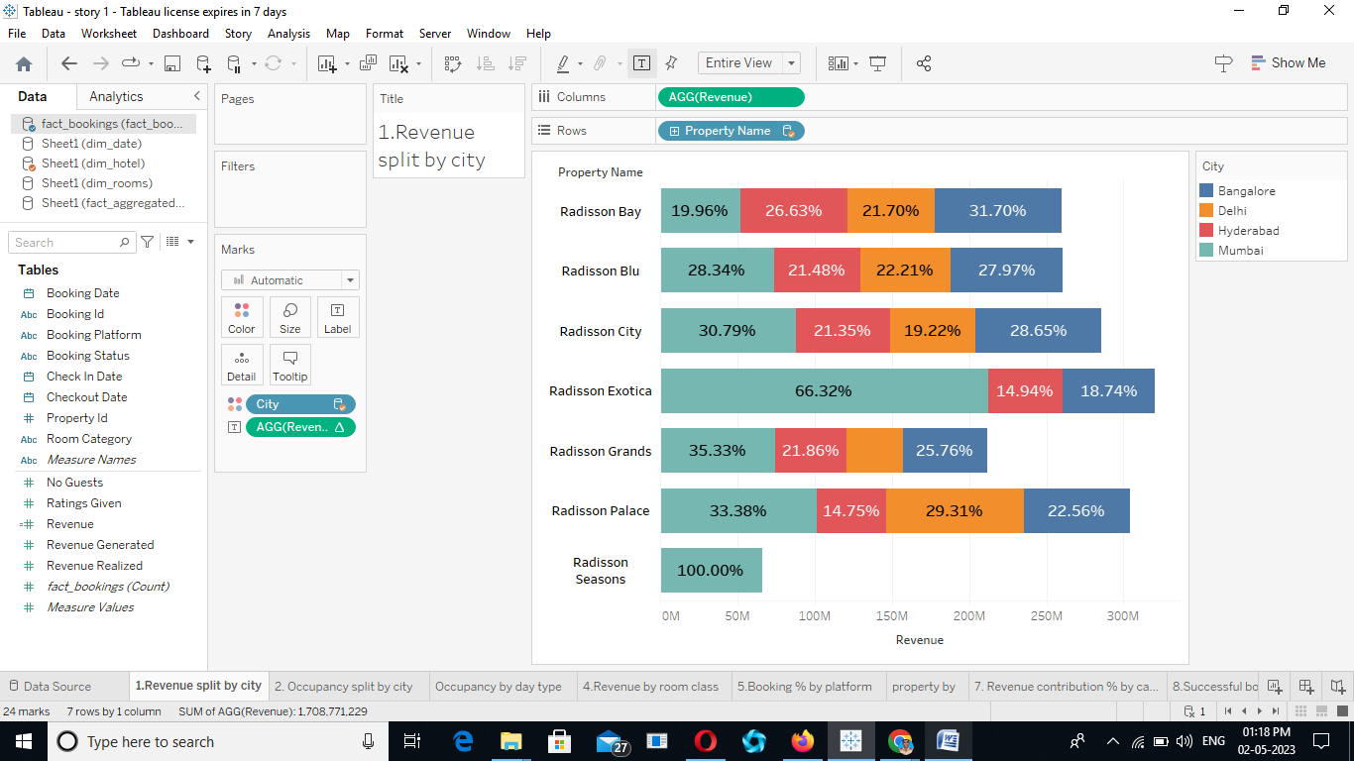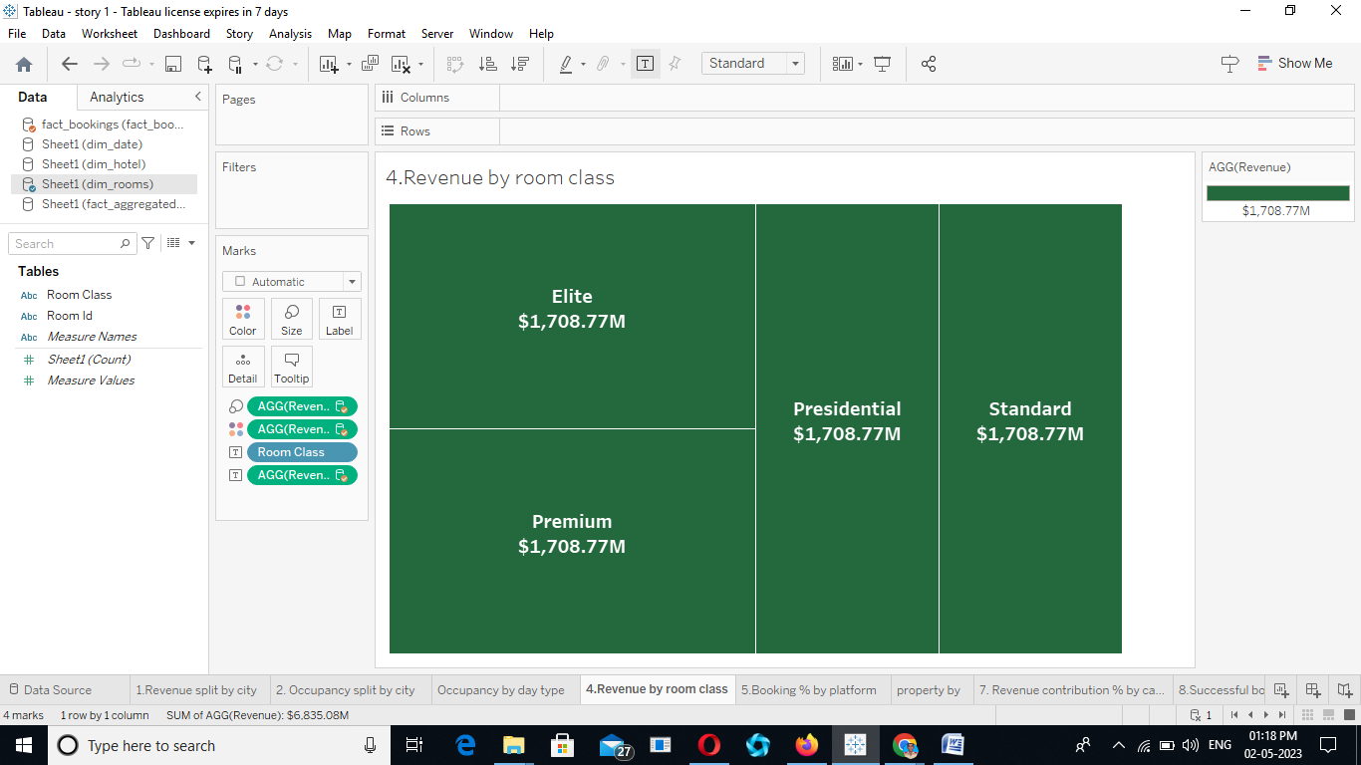

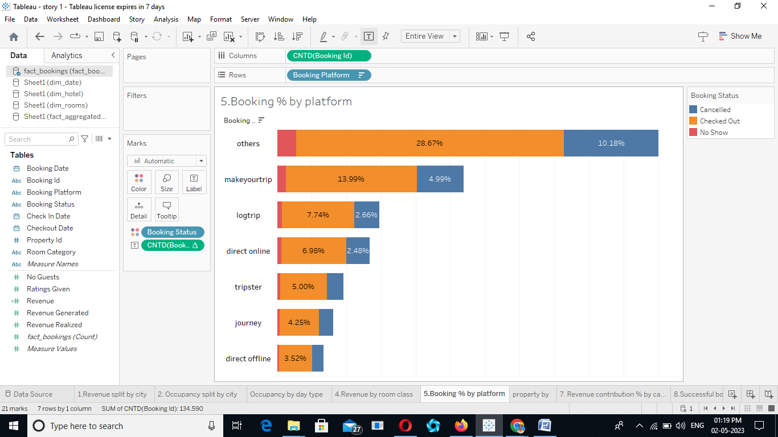

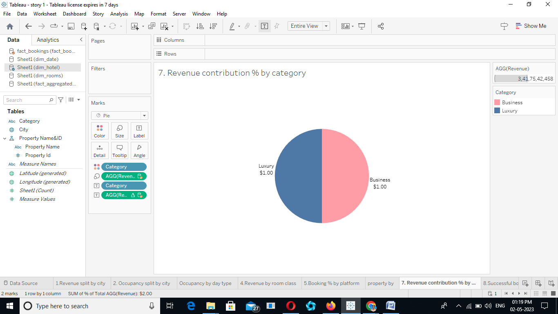

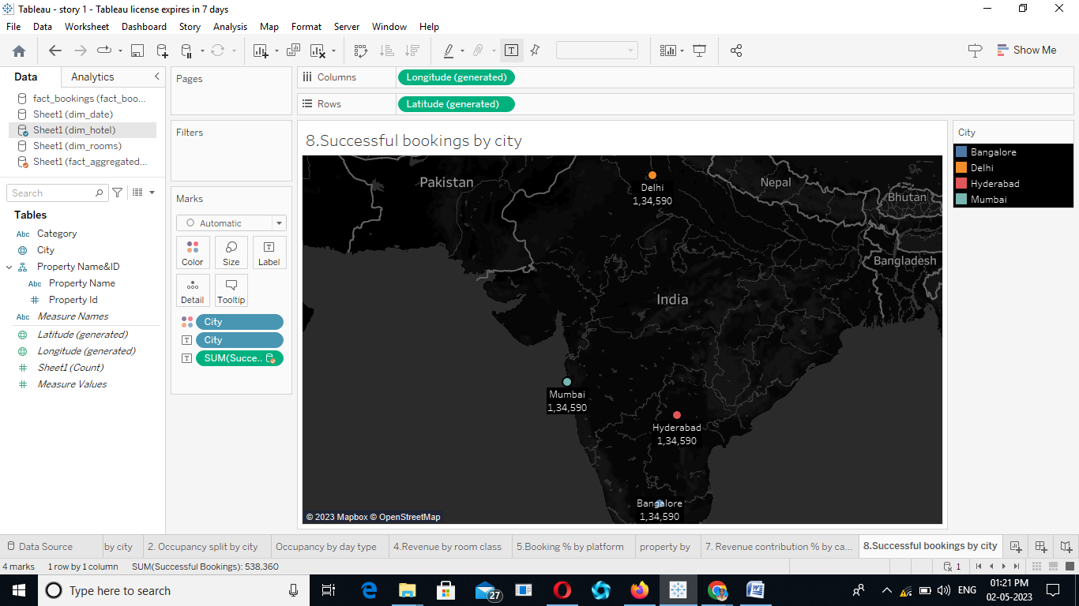

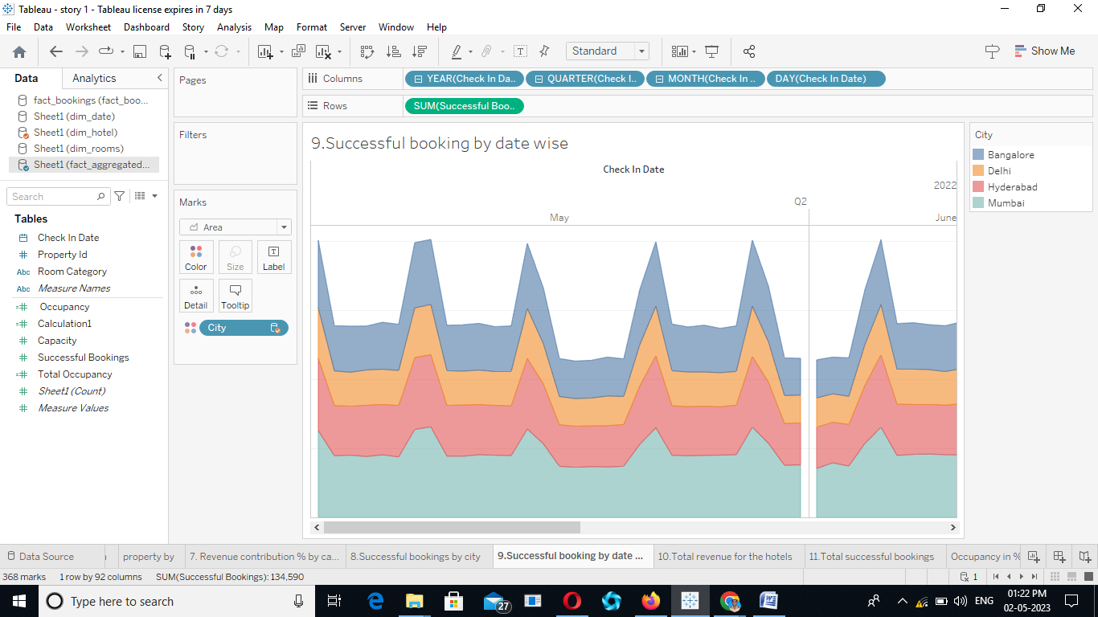

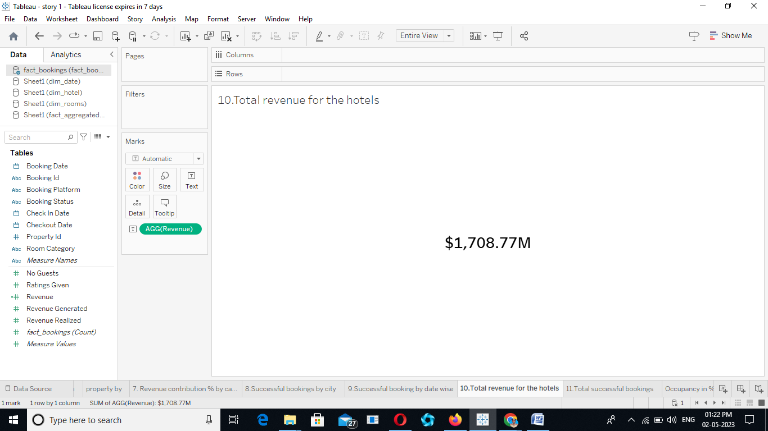



DASHBOARD:  
 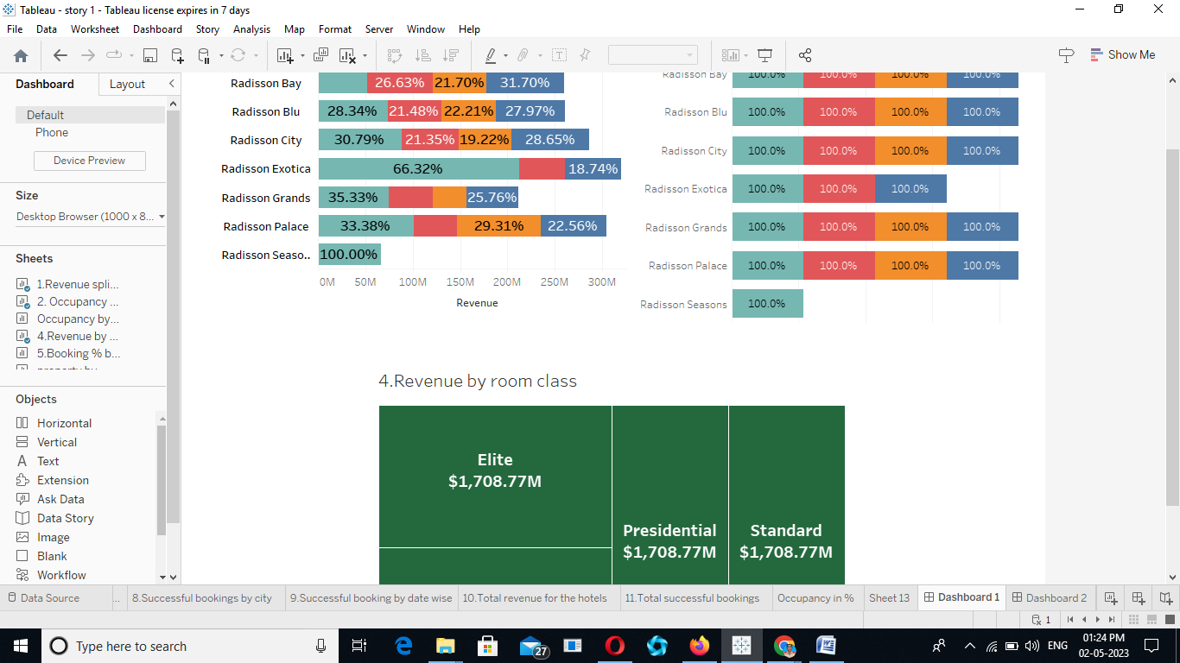

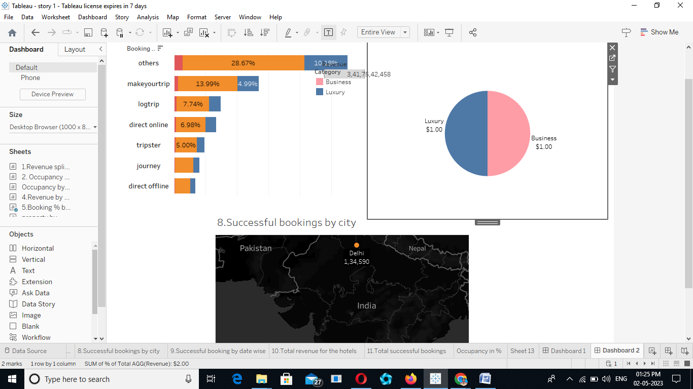

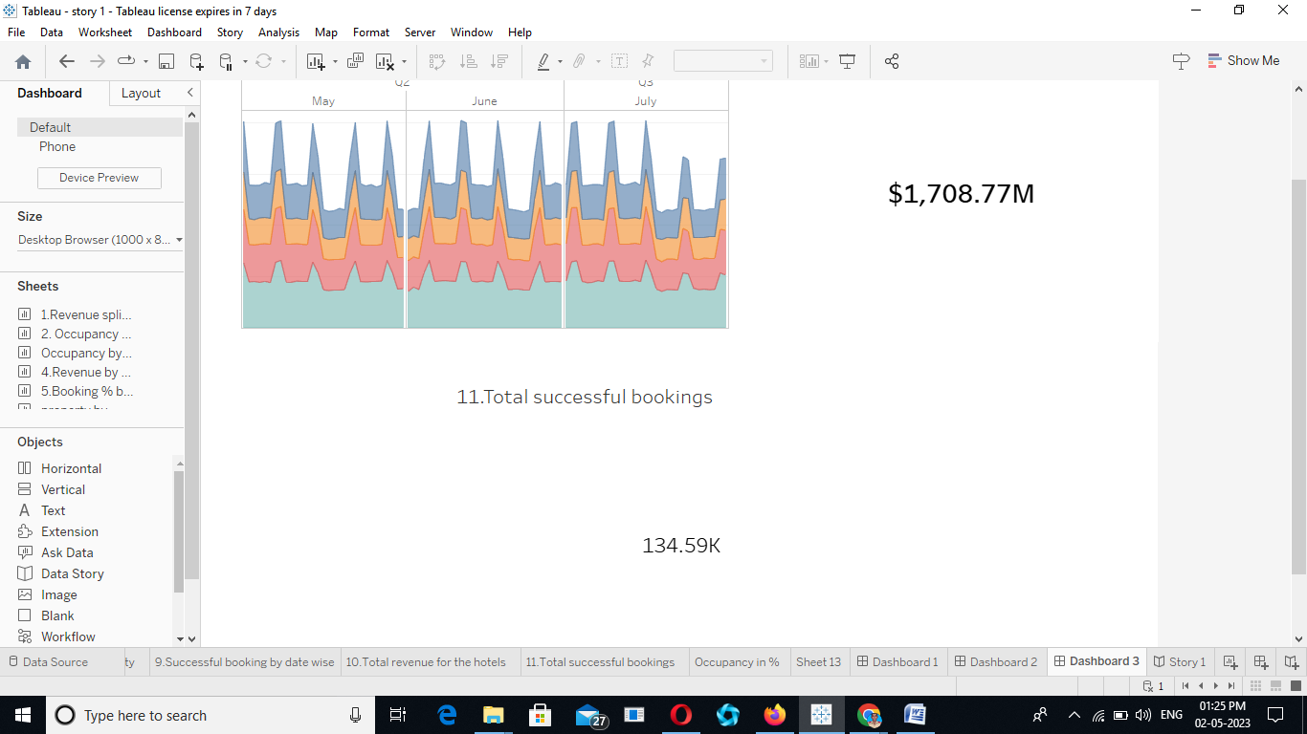

STORY:

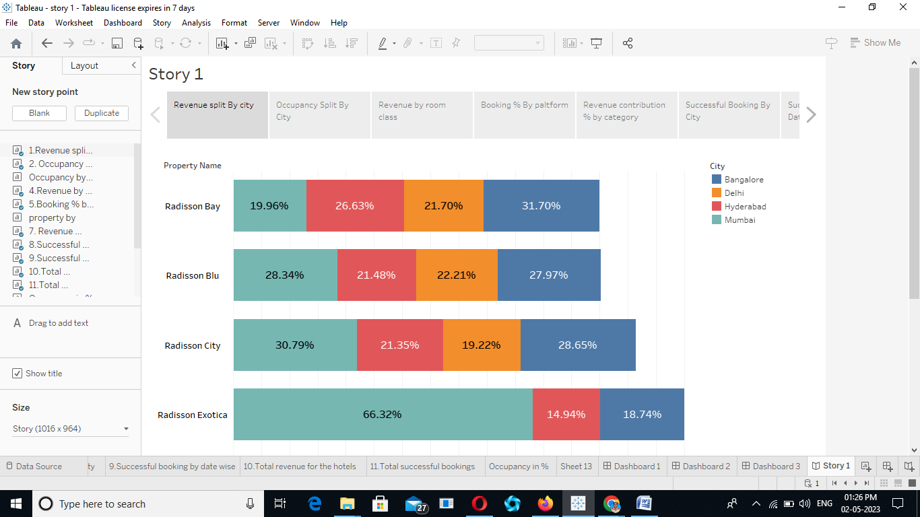

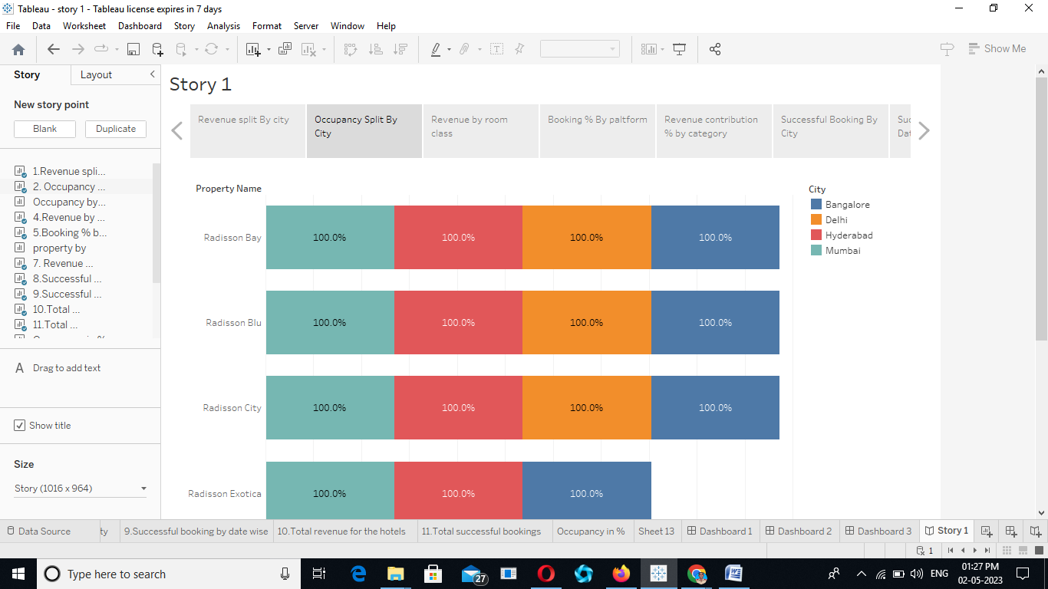

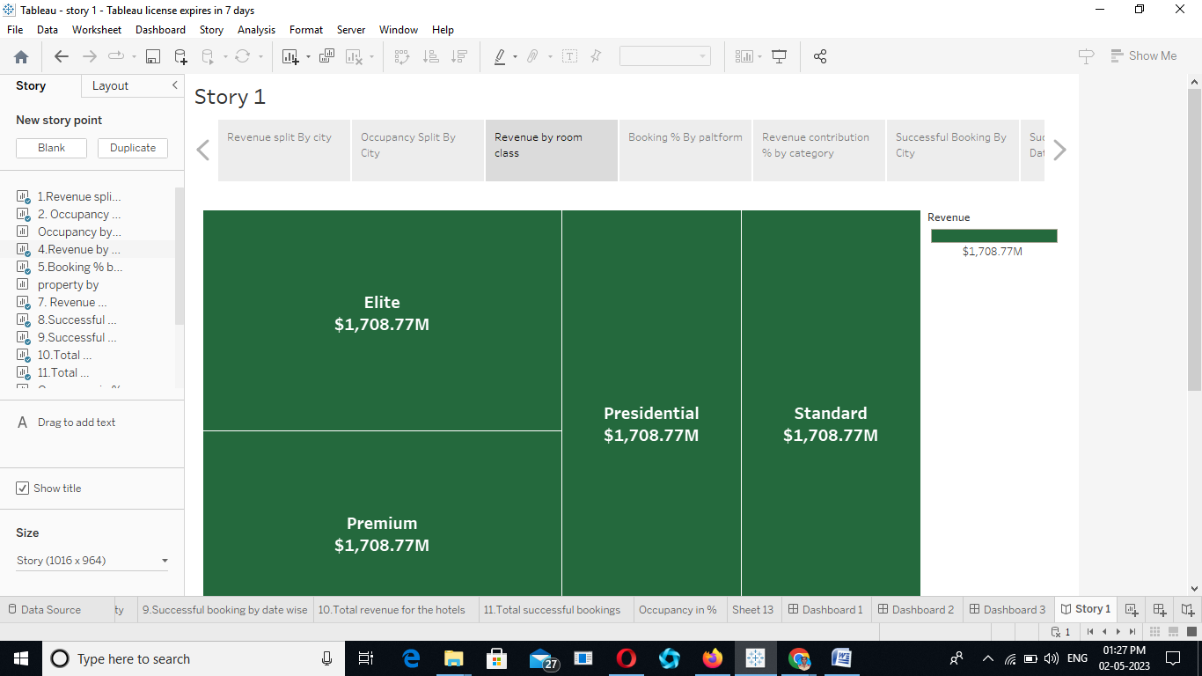

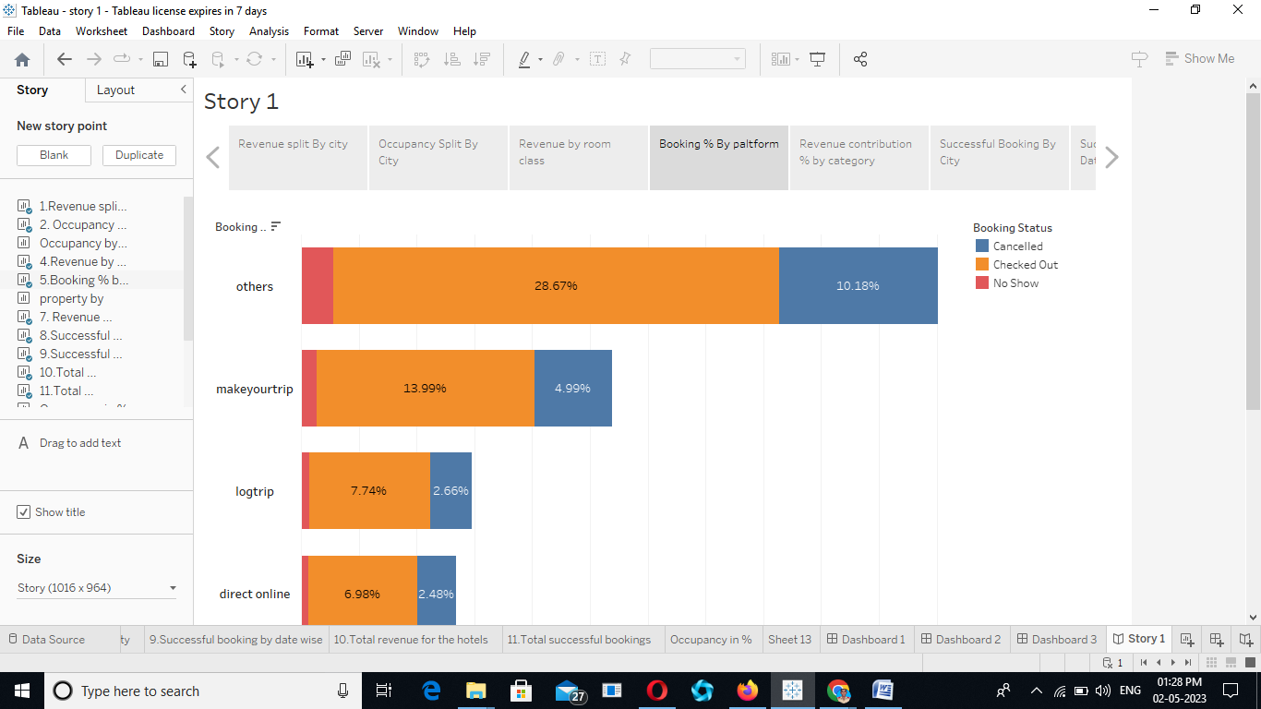

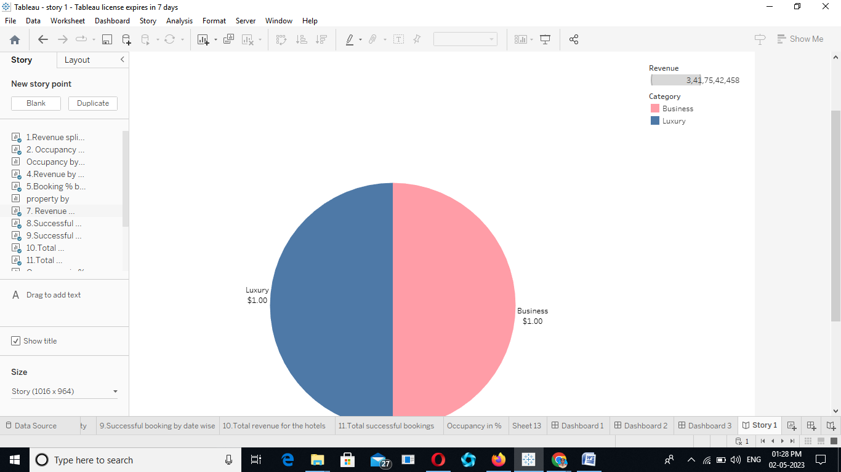

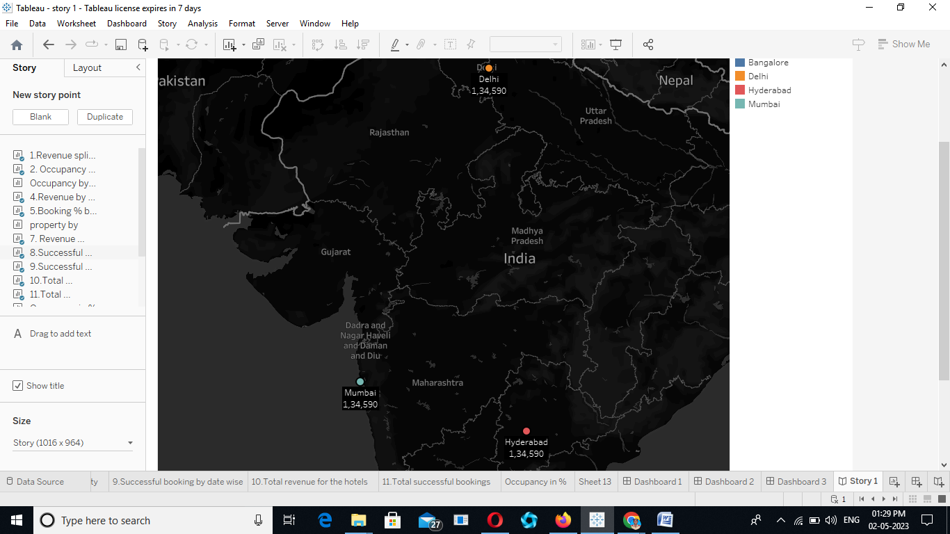

Data visualization is entering a new era. Emerging sources of intelligence, theoretical developments and advances in multidimensional imaging are reshaping the potential value that analytics and insights can provide, with visualization playing a key role. The principles of effective data visualization won’t change. However, nextgen technologies and evolving cognitive frameworks are opening new horizons, moving data visualization from art to science.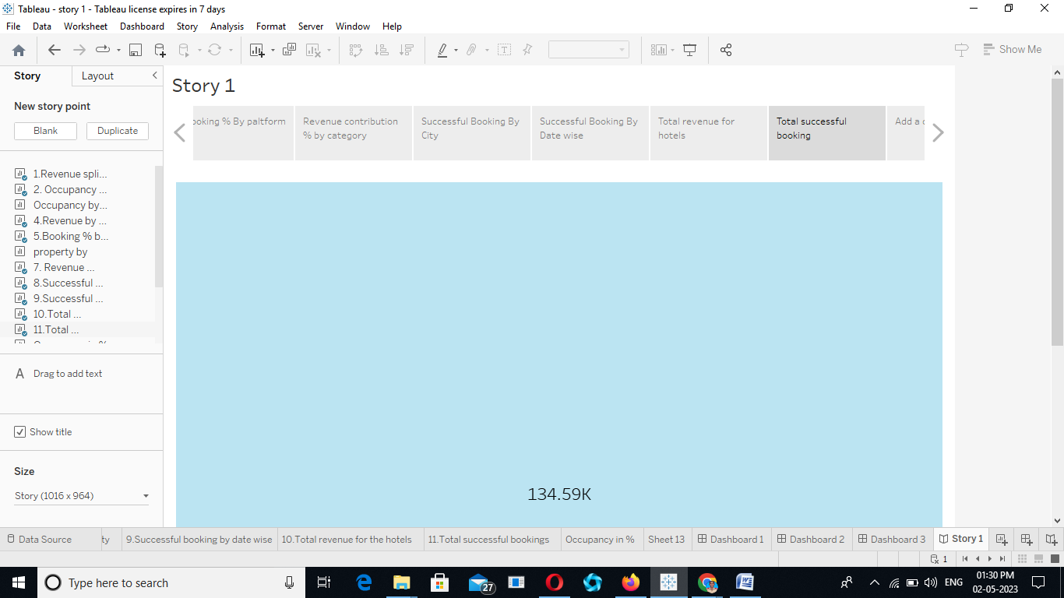

CONCLUSION:

Data visualization is entering a new era. Emerging sources of intelligence, theoretical developments and advances in multidimensional imaging are reshaping the potential value that analytics and insights can provide, with visualization playing a key role. The principles of effective data visualization won’t change. However, nextgen technologies and evolving cognitive frameworks are opening new horizons, moving data visualization from art to science.